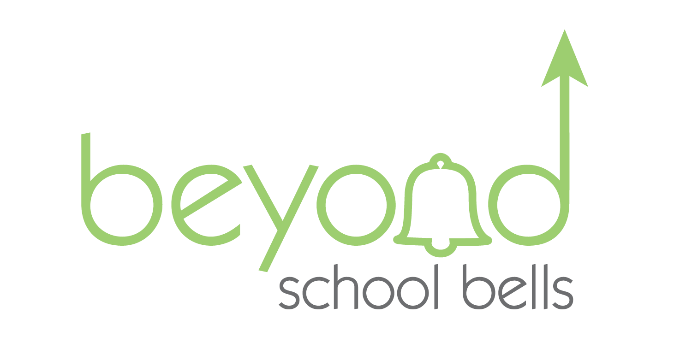
Getting Started: LOCAL PARTNERSHIPS

School-based ELO programs and community partnerships are relationships that are mutually beneficial, collaborative in nature, and result in achieving identified goals of those involved.
- Partners can be found in all Nebraska communities—rural and urban—and include local, regional, state and national entities from the public, private and nonprofit sectors.
- Authentic relationships between school-based programs, families, and partners can be both formal and informal, involve two-way communication, a shared vision, and consider the culture and diversity of the community.
- Sustainable partnerships grow in strength over time and reflect the efforts and commitment of those involved, despite changes in individual participants and membership.
- Important outcomes of partnerships are academic growth, health and physical well-being, and social emotional learning of all Nebraska students.
It is not lost on school leadership that community partnerships are important and necessary for the success of your students; however, it is often difficult to know where to start or how to expand beyond current community partnerships. This document is intended to provide a road map for the initial steps of getting started in the process of identifying, developing and initiating community partnerships. The recommendations highlighted in this document are designed to help schools plan and navigate the beginning stages of partnership development.

DEFINING PARTNERSHIPS
Before cultivating or committing to a partnership with a community-based entity, program leadership must first understand the nature of partnerships—as well as the different forms partnerships can take—relative to educational contexts. The partnership should be centered upon mutual collaboration, which involves a commitment of resources, services, and collaborative efforts to support a predefined need or goal. Further, a partnership is beneficial to all parties—both the school-based program and community partner.
In considering how to engage and work with community partners, program leaders will need to reflect on what needs exist in their school organizational operations (e.g., academic, college/career readiness, afterschool/summer programming, mental health, social supports, etc) that would be beneficial to fill for their students, families, and staff members. By identifying areas of need, school-based programs can better articulate the types of partnerships they seek with community-based organizations and gauge the specific benefits and services they seek to gain from and can provide to partnering organizations.

Characteristics of Strong community Partnerships
CHARACTERISTIC | DESCRIPTION
  Focus on Students | Students First.  School-based programs and their partners approach their work with a commitment to putting students' needs first.
  Leveraging of Strengths | Build upon strengths.  School-based programs and their partners identify their respective strengths and weaknesses, based on past experience and existing evidence, to provide a continuum of services and supports to students, staff, and families while minimizing duplicative efforts.
  Leadership and Oversight | Administrative Organization.  School-based programs and their partners compose common memos of understanding and service agreements. They also outline a clear framework for overseeing their partnership, whether by designating individual personnel or forming a committee to guide the partnership.
  Open  Communication | Clear, open communication.  School-based programs and their partners build and maintain two-way communication channels and emphasize mutual trust, transparency, and a commitment to high-quality programs as key aspects of their collaboration.
  Sustained Duration | Avoid focusing on one-time partnerships.  School-based programs and their partners commit to multi-year partnerships to support continuity of programming and guide sustained progress toward partnership goals.
Source: National Commission on Social, Emotional, and Academic Development, Aspen Institute

Benefits of Community Partnerships
  Students & Families | Partnerships can benefit students and families by:  - Providing continuity of services across the day and year, easing school transitions and promoting improved attendance at school and in ELO and extracurricular programs;  - Facilitating access to a range of learning opportunities and developmental supports, providing opportunities for students and program staff alike to experiment with new approaches to teaching and learning;  - Facilitating information sharing about specific students to best support individual learning; and  - Providing family members with alternative entry points into the school environment to support students' learning.
  Districts & Schools | Partnerships can benefit districts and school-based programs by:  - Complementing the curriculum with a wider range of services and activities, particularly enrichment and arts activities that may not typically be available during the school day;  - Supporting transitions across school years;  - Reinforcing concepts taught in school and exposing staff to new pedagogies and resources;  - Improving program culture and community image through exhibitions and performances that help “shine the light” on students whose talents may not be apparent in the classroom.
  Community Partners | Partnerships can benefit community partners by:  - Helping partners gain access to and recruit groups of students most in need of their support and services;  - Improving program quality and staff engagement, particularly when there is crossover between school and community organization staff;  - Fostering better alignment of school-based and community programming to support a shared vision for learning, one which aligns curriculum to support state and local standards; and  - Maximizing resource use such as facilities, staff, data, and curriculum.
Source: The Expanded Learning and Afterschool Project

MOVING FORWARD…

As a school-based program, we understand the importance of community partnerships. NOW WHAT?

IDENTIFYING Areas of Need & Potential Partnership Opportunities

A school-community partnership can focus on a range of potential areas such as afterschool/summer programming, academic tutoring, work-based learning for students, mental health services, or the provision of student basic necessities and school supplies. In identifying a need/s, schools can begin to think of potential partners and conduct outreach to the community/potentials partners to determine what organizations or individuals have the expertise and resource capacity to address defined areas of need. Prior to starting the process of identifying potential partners, there may be a need for your school to establish a short-term advisory team. With or without this advisory team, it is important to walk through these questions prior to identifying potential partners.

Advisory Team
- Do we already have a leadership team available to serve in this capacity? Should we create a new team? If so, then:
  - Who needs to be on the team? Who will lead the team? Is school leadership represented?
  - Are the people who know the community best on our team?
  - Are students/student voice included in this team?

- Is our school-based program not in a place to form a formal advisory team? This may be the case—do not let this be a stopping place from your school moving forward. The following work can still be done by a lead staff member/s , with input from other key school personnel.

Identifying and Clarifying Needs & Expectations
- What are our needs? Should needs assessment be conducted?
- What do we hope to achieve?
- What do we want our school-community partnership to look like?
- What do we believe about partnering with community entities? What do we know about what our communities want? What research and/or data do we have? (Other school surveys etc)
Identifying Current Strengths & Resources
- Who do we already have partnerships with that we can build upon?
- Where is community engagement happening now? Where is it working for us?
- How do we offer a diverse array of engagement opportunities?
- How would potential partners support our school’s improvement goals? (MTSS/PBIS, School Improvement, Afterschool, Attendance, Safety, Learning and Engagement, Communication)
- How can we intentionally connect to the needs and abilities of all the community in engaging them? What do we know about our communities' needs/wants?
- Who are the influencers in our community—who do we have on our team/school who already has a relationship with the influencers?

IDENTIFYING POTENTIAL PARTNERS

Generalized Questions to Consider For Partner Identification
Source: The Education Alliance, Brown University

Potential Community Partners: Urban and RURAL
- Local colleges or universities
- UNL 4H Extension
- Banks/Credit Unions
- Healthcare Providers
- Environmental Groups/Businesses; NE Game & Parks
- Private Businesses and Industries
  - Chamber of Commerce
- Nonprofit Institutions
- Religious Organizations
- Local Media
- Community Centers
- Local Government & Services
  - Mayor’s Office, City Council, Police Dept, Parks and Rec, Library, Health and Human Services Dept
- State Agencies
- Influential Individuals
- Local or State Foundations
- Agriculture-Based Businesses (farms, ranches, etc)
- Retirement Centers
- Service Based Organizations (Rotary, PEO, Elks, etc)

TOOL: BSB Community Scan Document
Created by Beyond School Bells, this tool allows for your school to start the process of mapping out potential community partners. These are just sample potential partners to help you begin this mapping experience, complete the chart as it aligns to your community and possible partner organizations.

Name of business or organization | Previous communication has occurred | Previous partnership has existed | Direct personal connection(s)* | Indirect personal connection(s)** | Contact person***
Hospital
Local Bank
Mayor’s Office
City Council
School Board
Library
Parks & Rec
Police Dept
Local Church
Local College
Local Museum
Industry/ Large Community Employer
Chamber of Commerce
Service Organizations: Rotary /Elks Club
4-H Extension
Grocery Store
Health & Human Svc.
Local YMCA
Auto Dealership
Electric Co.
Co-op Office
Farms/Ranches

TOOL: BSB Partner analysis Document
After utilizing the COMMUNITY SCAN tool, identify 2-3 potential partners. Use this tool to process how these partners can benefit/contribute to your school. When you can clearly spell out the benefits of partnering with your school, partners will be much more likely to want to participate. If they have previously partnered with your school, think about how you might encourage them to take their involvement to the next level.
Potential Partner Name:_______________________________________________________________
What can this partner offer our school? Identify resources, services, or materials. | How might this partner benefit from a partnership with our school? What does our school bring to the partnership? Identify ways to mutually collaborate and benefit from a partnership. | What is our specific “ask” of this partner? How do we envision our partnership?

Potential Partner Name:_________________________________________________________________
What can this partner offer our school? Identify resources, services, or materials. | How might this partner benefit from a partnership with our school? What does our school bring to the partnership? Identify ways to mutually collaborate and benefit from a partnership. | What is our specific “ask” of this partner? How do we envision our partnership?

Potential Partner Name:_________________________________________________________________
What can this partner offer our school? Identify resources, services, or materials. | How might this partner benefit from a partnership with our school? What does our school bring to the partnership? Identify ways to mutually collaborate and benefit from a partnership. | What is our specific “ask” of this partner? How do we envision our partnership?

ENgaging Potential PArtners

Initiate contact to introduce the idea of the potential partnership—draft a basic partnership proposal
Once you have identified a potential partner/s, it is important to be thoughtful and purposeful in your efforts to engage this partner. While connecting personally—be it an initial phone call, meeting, or informal discussion—it is always helpful to provide your potential partner with a written proposal for their consideration. This does not need to be a long and detailed document, rather just a basic concept that you would like them to consider in terms of a potential partnership. This may be done in an email and briefly introduce the concept.
Additionally, provide them with written and video (if available) resources that highlight your school—this could be school district brochure, brief overview video, one page overview, website link to school home page, etc. After you have had an initial contact introducing the general concept of the potential partnership and have provided them with a basic written proposal, set up a meeting to discuss the partnership in more detail and the mutual context of the partnership.

Laying the foundation: Discussing the potential partnership in greater detail
As you enter these conversations, keep in mind that all partnerships should be driven by what’s best for students and that the most successful partnerships offer “win-win” benefits for the school and community partners as well. This is the place to dive into the details of what your school needs are and how you envision this partnership helping to address those needs. It is the opportunity for the community partner to lay out their needs/wants and how they envision this partnership. While clear objectives need to be discussed, this is a time to also allow brainstorming to occur with the community partner—they may have a new idea or concept for their partnership that had not been thought of/presented by the school. Allow for collaboration to occur in these discussions—mutually collaborate partnerships are always more successful.
As a school, seek a clear understanding of the amount of time the community partner expects to contribute to the effort. Understanding the availability of the community partner will help your school to utilize the community partners’ time in the manner most productive for the partnership. The initial partnership may be short-term in a nature (a certain event) or long-term—regardless of the nature of the partnership, clear communication prior to the implementation of a partnership is critical to its success.

Ensure a shared vision: Define short- and long-range goals of partnership, including expected outcomes.
Prior to implementation, taking time to clearly lay out the partnership in terms of goals and outcomes is essential. Defining the goals of your partnership—short and long term—based on the needs and desired outcomes for each partner helps to ensure that there is a shared vision in this new partnership.

TOOL: BSB DEVELOPING A SHARED VISION DOCUMENT
Utilize the tool below to help with outlining the shared vision of your community partnership. The focus and work of your partnership may only have one goal, or it could have multiple goals. This document will also help serves as a guide in your implementation and evaluation phases of this partnership.
Identified Needs:
Resources:
GOAL 1: |  | GOAL 2: | GOAL 3:
OBJECTIVES: |  | OBJECTIVES: | OBJECTIVES:
OUTCOMES: |  | OUTCOMES: | OUTCOMES:

