Guidelines for Hiring Afterschool Staff
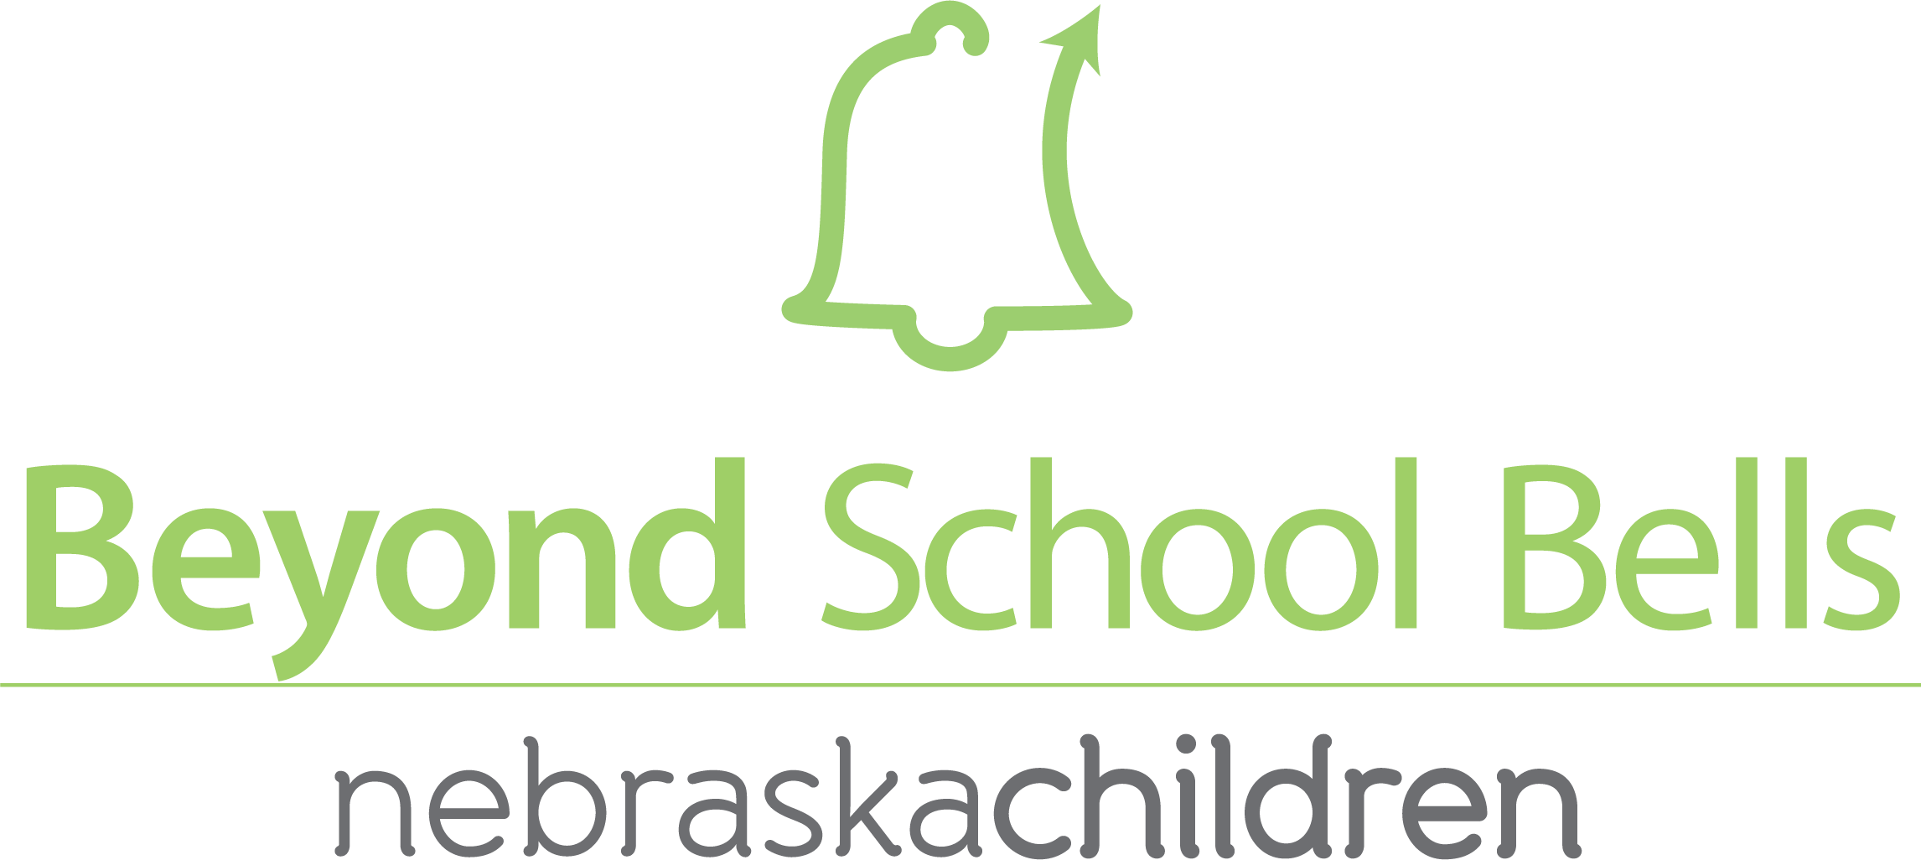

Here you will find suggestions that will guide you in your selection
or creation of interview questions appropriate for your program.

- The Afterschool program staff interview should consist of 8-10 questions.
- Provide the candidate with the opportunity to ask questions at the end of the interview.
- Also, ask the candidate to provide professional references.
- Refer to licensure policies and school policies regarding background checks for staff working with students.

Program Staff Interview Questions
- Describe your background, education and career experiences.
- Do you have any experiences working with after school programs?
- Why are you interested in this position?
- How do you build relationships with the students you work with?
- What types of classes or activities can you offer?
- What is the maximum number of participants that you can have in your class or activity?
- How do you set behavior expectations with students?
- How would you respond to a student who does not follow directions?
- What techniques to you use to motivate students to learn?
- Describe a time you have taught social skills.
- Describe a time you have worked or volunteered in a teamwork environment.
- What languages do you speak?
- Are you certified in CPR? First Aid? Other certifications?
- What are your strengths? Weaknesses?
- What is your availability before and after the school day?

Tips of Hiring Staff from current Afterschool Directors:
- Always have a back-up plan.
- Look for staff who are energetic, passionate, kid-friendly, creative and committed.
- Recruit the teachers who have a great rapport with the students.
- Hire based on the program’s needs, not on the applicant’s needs.
- Seek diversity and those who are flexible.
- Make sure you are clear on your expectations and the expected duties upfront. » Be sure to check their references.
- Sometimes you never really know someone until three months into it – don’t be afraid to let go of those who are not working out.

